’

Project
  - Deadline: Monday 09/08/2026 @ 23:59
[Total Mark is 20]

Introduction to Database
CS350
Instructions:
- You must submit two separate copies (one Word file and one PDF file) using the Assignment Template on Blackboard via the allocated folder. These files must not be in compressed format.
- It is your responsibility to check and make sure that you have uploaded both the correct files.
- Zero mark will be given if you try to bypass the SafeAssign (e.g. misspell words, remove spaces between words, hide characters, use different character sets, convert text into image or languages other than English or any kind of manipulation).
- Email submission will not be accepted.
- You are advised to make your work clear and well-presented. This includes filling your information on the cover page.
- You must use this template, failing which will result in zero mark.
- You MUST show all your work, and text must not be converted into an image, unless specified otherwise by the question.
- Late submission will result in ZERO mark.
- The work should be your own, copying from students or other resources will result in ZERO mark.
- Use Times New Roman font for all your answers.
Student Details: CRN:
Name: Osama Alqhtani  Name: saud turki aldossary  Name: M Ali Arabi  Name: Omar Balatif |  | ID: S230036348  ID: S230061191  ID: 240010732  ID: 240022075

Project Instructions
- You can work on this project as a group (minimum 3 and maximum 4 students). Each group member must submit the project individually with all group member names mentioned on the cover page.
- This project worth 20 marks and will be distributed as in the following:
  - Database Design. (6 marks)
  - Database Implementation. (6 marks)
  - SQL Operations. (6 marks)
  - Project Reflection. (2 marks)
- Each leader in the group must submit one report about their chosen Project via the Blackboard (Email submission will not be accepted and will be awarded ZERO marks) containing the following:
- Task 1 : database design
- Task 2: database implementation
- All requested queries/results
- Screenshots from MySQL (or any other software you use) of all the tables after population and query results.
- Reflection (300–500 words) describing the team's experience, challenges, design decisions, and AI usage (if applicable).
- Submit one SQL file containing the complete database implementation, including database creation, tables, data insertion, required queries, VIEW, and TRIGGER.
- Submit a GitHub (or GitLab) repository containing the complete project with regular commits and meaningful commit messages.
- Submit a progress report describing the completed work, key decisions, challenges, future plan, and contribution of each group member.
- Include links to the live report document, GitHub/GitLab repository, and Google Colab notebook (if applicable) in the Project Artifacts section of the final report.
- You are advised to make your work clear and well presented; marks may be reduced for poor presentation. This includes filling in your information on the cover page.
- You MUST show all your work, and text must not be converted into an image unless specified otherwise by the question.
- Late submission will result in ZERO marks being awarded.
- The work should be your own. Copying from students or other resources, including AI software, will result in ZERO marks.

Project Description
Design and Implementation of a Smart Clinic Database System
Learning Outcome(s):

CLO1, CLO2, CLO3, CLO4, CLO5

A private clinic currently manages its patient information manually, making it difficult to organize appointments, treatments, and payments. The clinic has decided to develop a database system to improve data organization and retrieval.
Your team is required to design, implement, and test a complete relational database using the concepts learned throughout this course. The project should demonstrate your understanding of database design, ER/EER modeling, relational mapping, SQL implementation, and advanced SQL queries. The project must be completed using MySQL.

Task 1 – Database Design (6 Marks)
- Design a complete database for the clinic that includes at least six entities such as Patients, Doctors, Appointments, Treatments, Medicines, Payments, or any other appropriate entities.
- A complete ER/EER diagram.
- Primary and foreign keys.
- Appropriate relationships with cardinality.
- At least one specialization/generalization (EER feature).
- Any assumptions made during the design process.

Entity | Attributes
Employee | EmployeeID, Name, ContactDetails
Doctor | Speciality
Reception | DeskNumber
Appointment | AppointmentID, ApptDate, Duration
Patient | PatientID, Name, ContactDetails
Payment | PaymentID, PayDate, Amount
Treatment | TreatmentID, Details
Medicine | MedicineID, Name, Stock

Relationships & Cardinalities
Relationship | Entities | Cardinality
(Standard for Subtypes) | Employee – Doctor, Reception | 1-1
Oversees | Doctor – Appointment | 1 – M
Results_In | Appointment – Treatment | 1 – 1
Books | Patient – Appointment | 1 – M
Requires Payment | Appointment – Payment | 1 – 1
Prescribes | Treatment – Medicine | M – M

Entity | Attribute Keys & Foreign Keys
Employee | EmployeeID (PK), Name, ContactDetails
Doctor | EmployeeID (PK, FK), Speciality
Receptionist | EmployeeID (PK, FK), DeskNumber
Patient | PatientID (PK), Name, ContactDetails
Appointment | AppointmentID (PK), ApptDate, Duration, PatientID (FK), EmployeeID_Doctor (FK)
Treatment | TreatmentID (PK), Details, AppointmentID (FK)
Medicine | MedicineID (PK), Name, Stock
Payment | PaymentID (PK), PayDate, Amount, AppointmentID (FK)
Treatment_Medicine | TreatmentID (PK, FK), MedicineID (PK, FK), Quantity

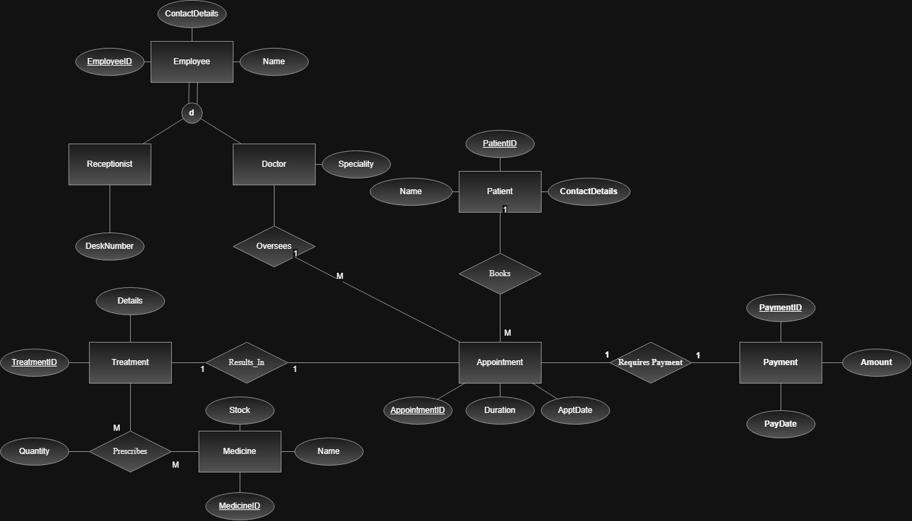
EER Diagram (made by wep draw io)

Task 2 – Database Implementation (6 Marks)
Complete the following tasks using MySQL. Include screenshots of both your SQL code and the corresponding output (results) for each task:
- Create the database and all required tables.
- Use appropriate data types and constraints (PRIMARY KEY, FOREIGN KEY, NOT NULL, UNIQUE, etc.).
- Insert at least 5 records into each main table.
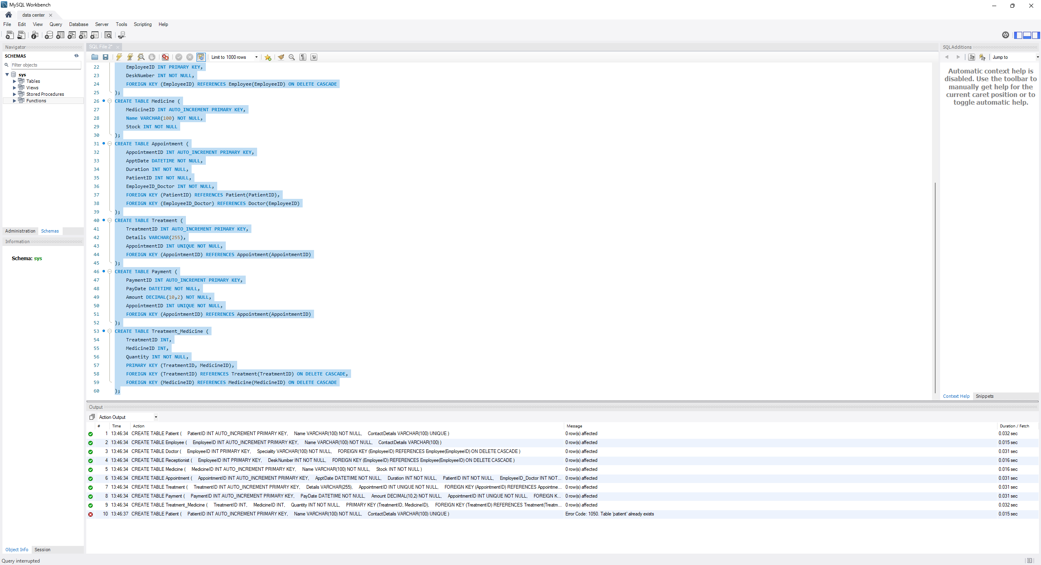
This code creates the core database tables for clinic appointments treatments payments and medicines while establishing primary and foreign key constraints to link them together properly

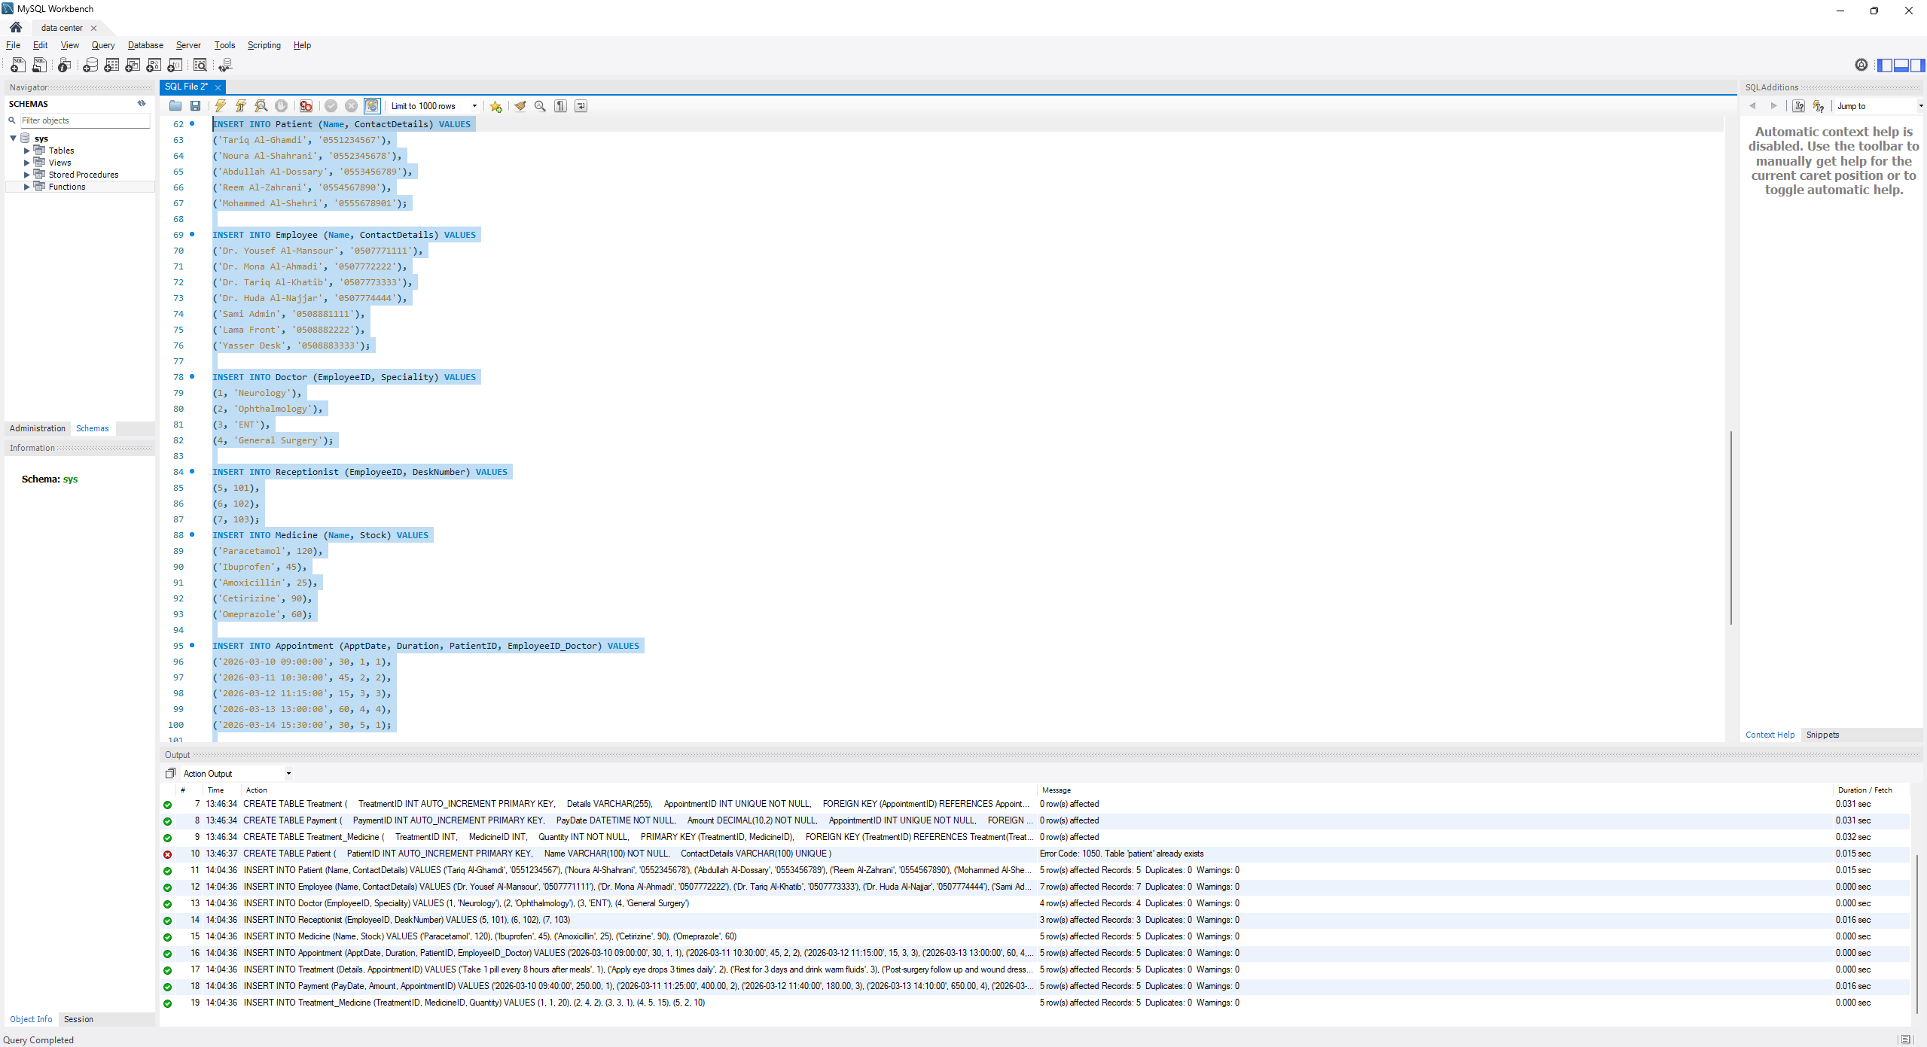

This code populates the clinic database by inserting initial sample records for patients, employees, specialized doctors, receptionists, medicines, and scheduled appointments

Task 3 – SQL Operations (6 Marks)
Complete the following tasks using MySQL. For each task, include screenshots of both your SQL code and the corresponding output (results), along with a brief description (one to two sentences) explaining the purpose of the query and the information it is intended to retrieve.
- Write SELECT statements.
- Write JOIN queries.
- Write nested queries.
- Use aggregate functions with GROUP BY.
- Write UPDATE and DELETE statements.
- Create one VIEW.
- Create one TRIGGER.

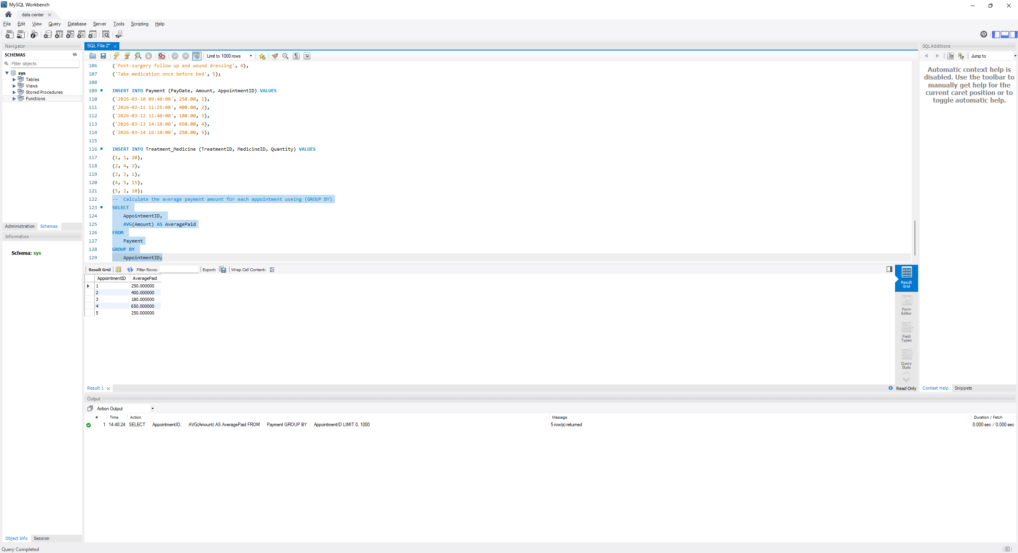This query groups records by appointment ID to calculate and display the average payment amount calculated for each appointment

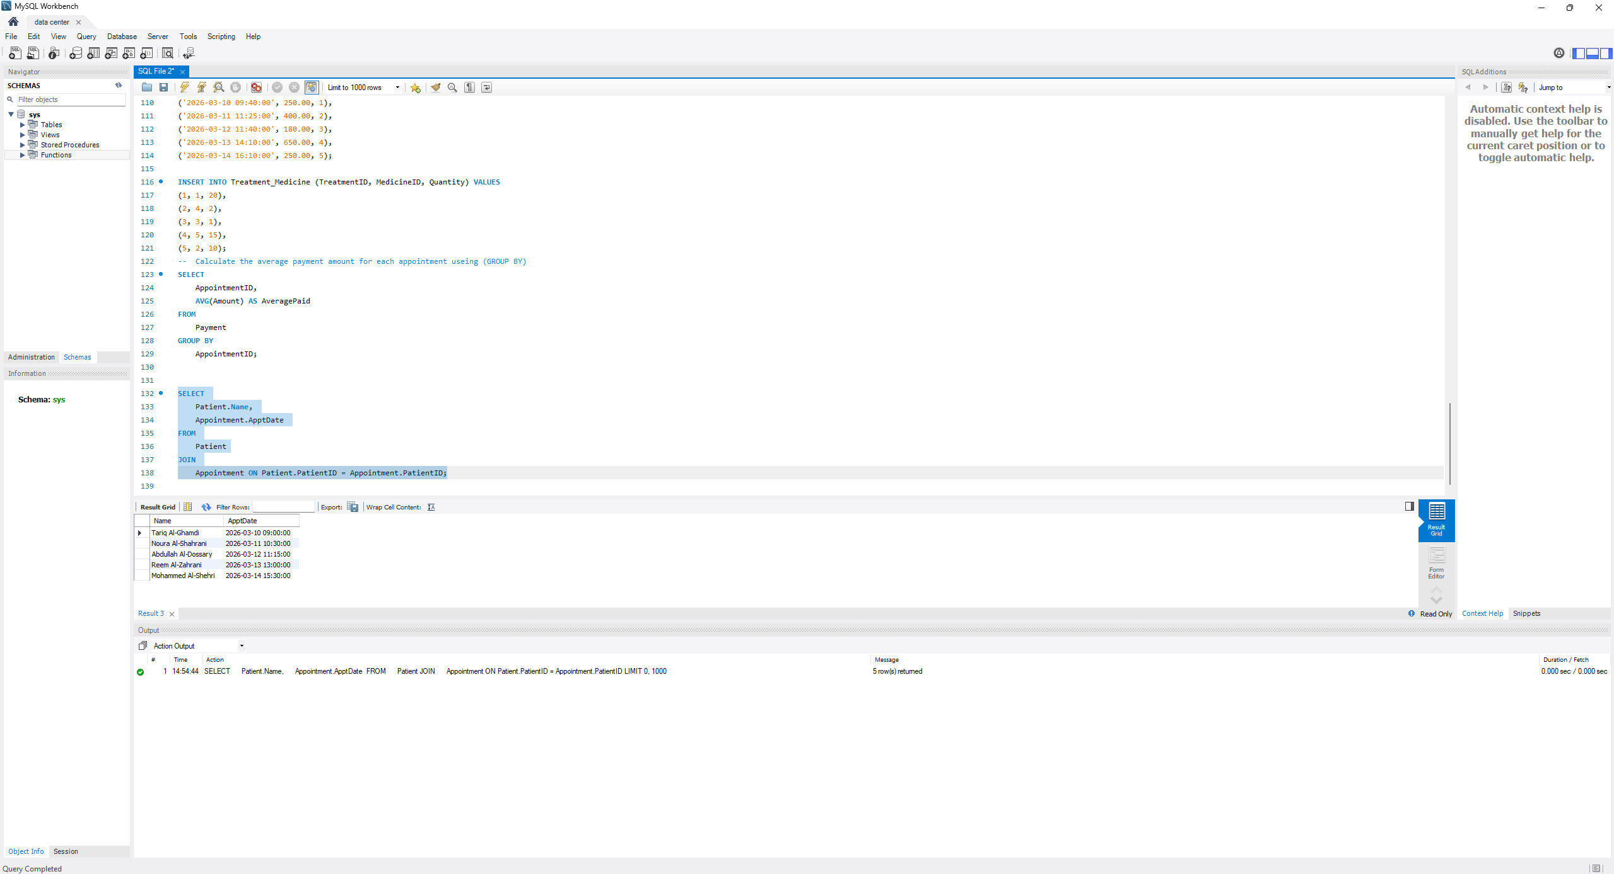

This query performs a JOIN between the Patient and Appointment tables to retrieve each patient's name along with their scheduled appointment date.
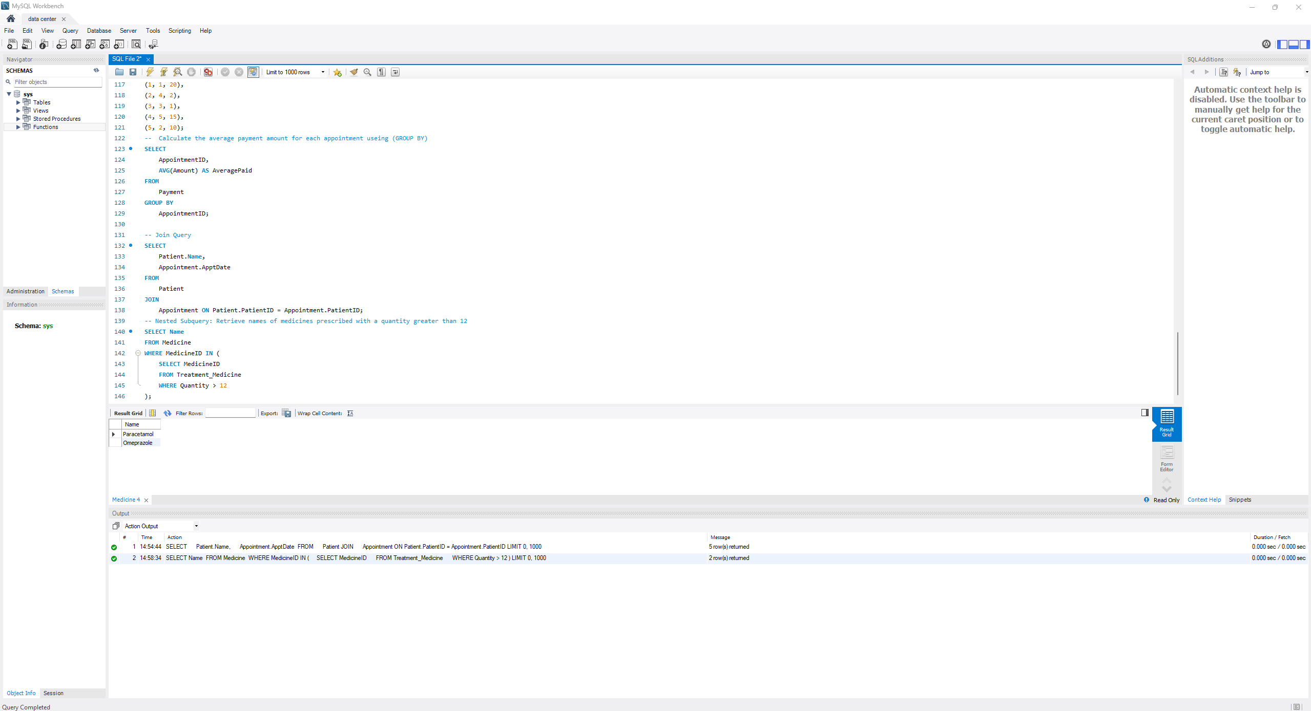
This nested subquery retrieves the names of medicines that have been prescribed in quantities exceeding 12 units by filtering MedicineID values from the Treatment_Medicine table

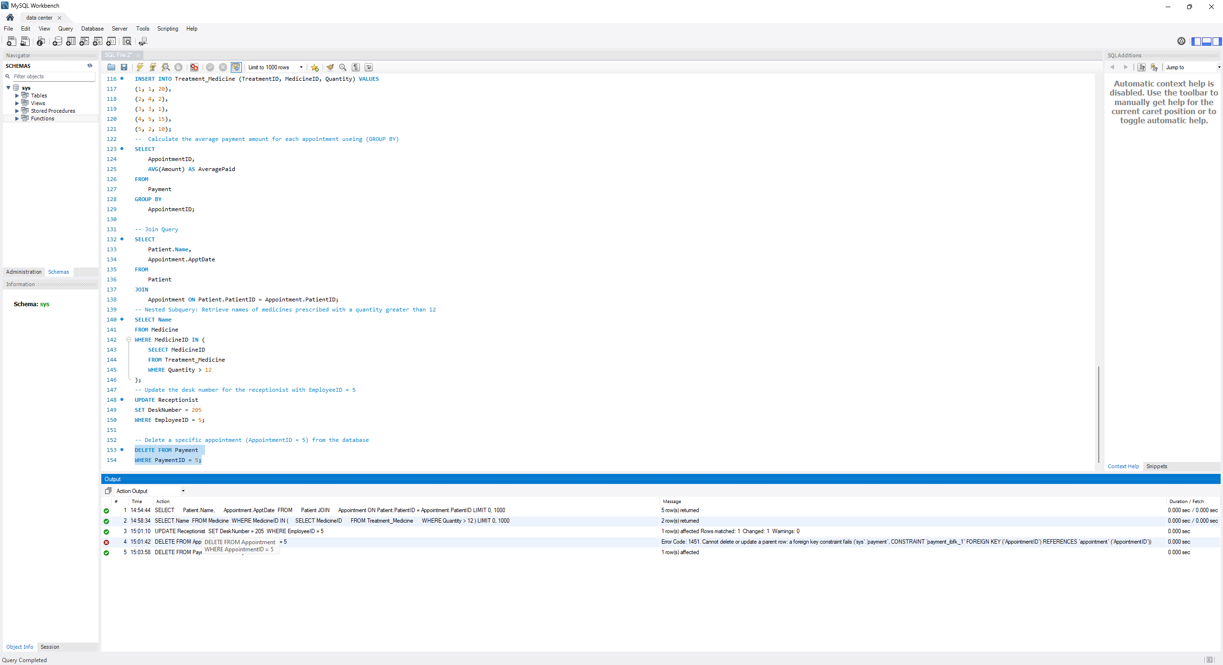
This DML code updates the desk number for receptionist #5 and removes a specific billing record (PaymentID = 5) directly from the Payment table

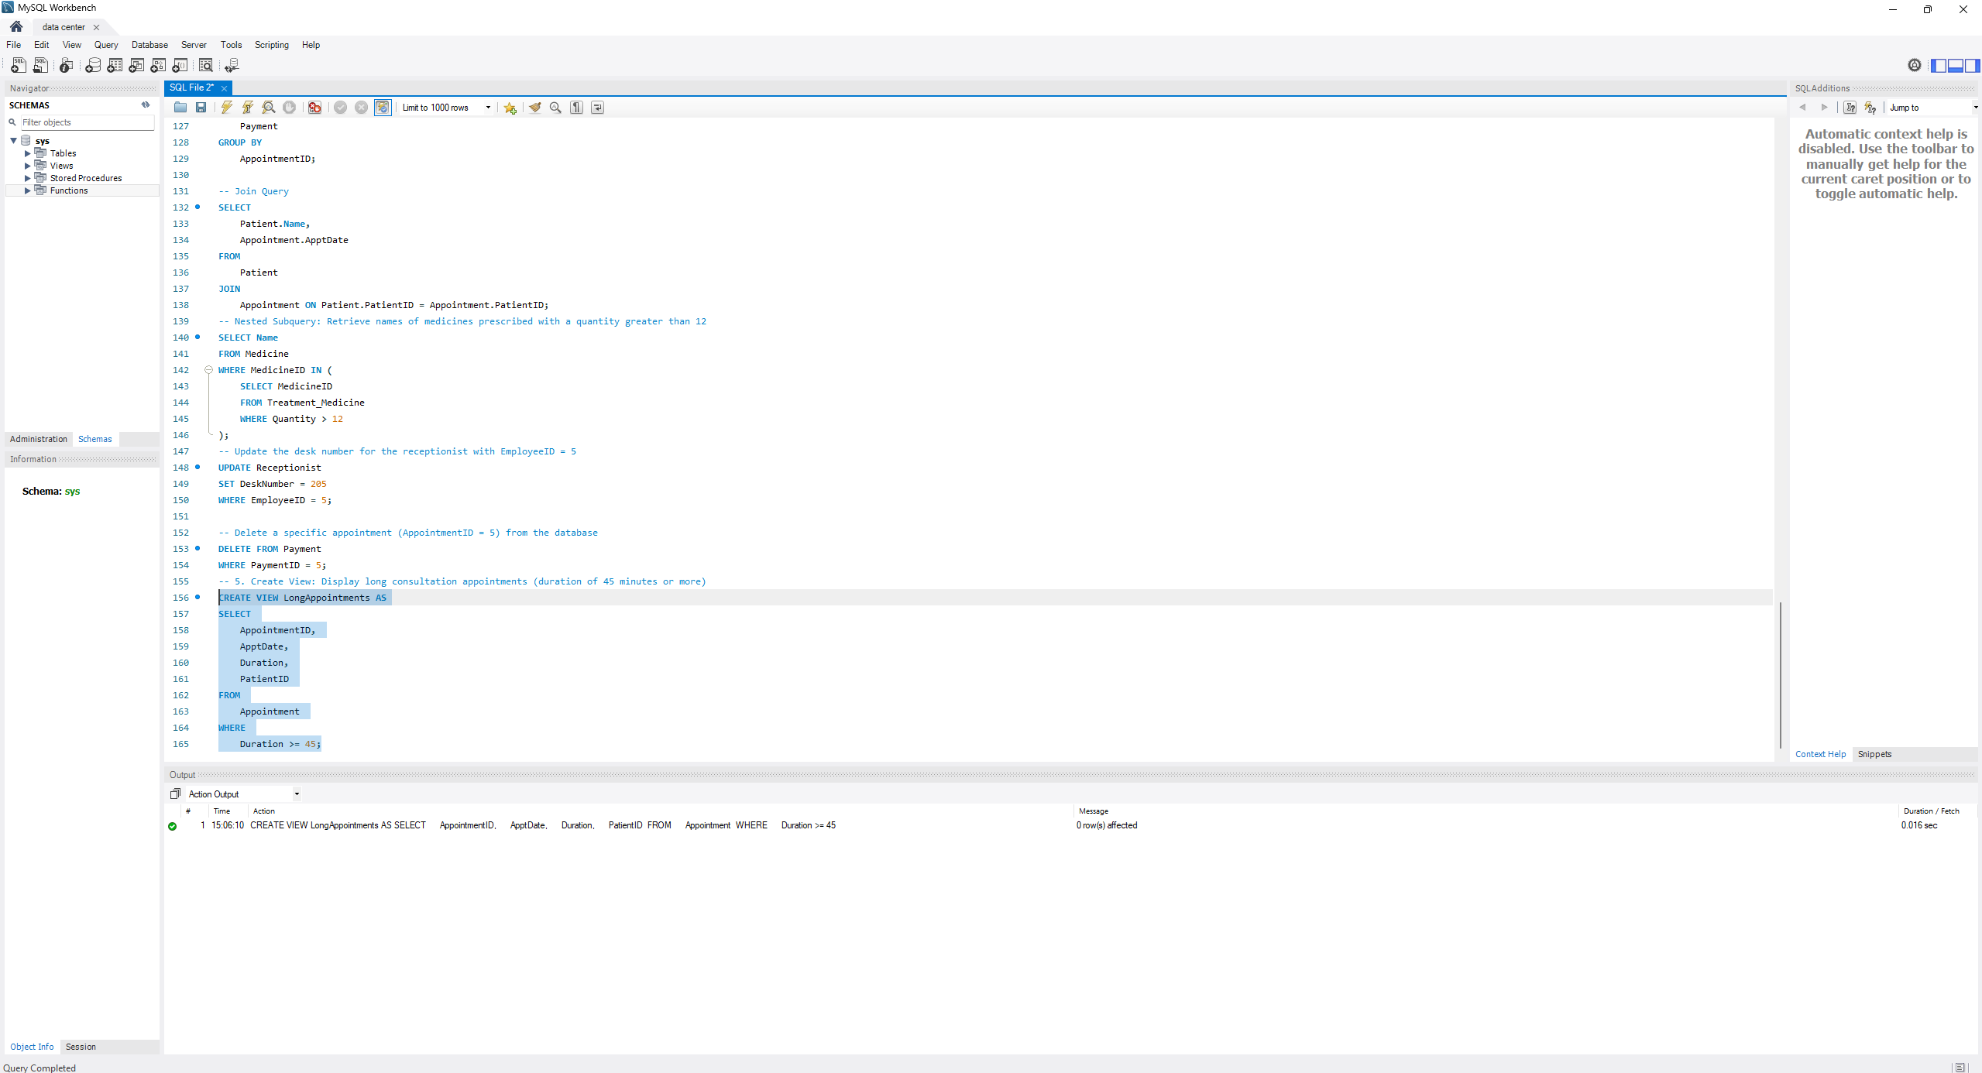
This query creates a saved view called LongAppointments that automatically filters for any medical visits lasting 45 minutes or more

Task 4 – Reflection (2 Marks)
Write a 300–500-word reflection on your experience while completing this project by
answering the following questions. Your responses should be clear, concise, and
supported with specific examples from your own work.
- Describe one specific challenge or obstacle you encountered during this project and explain in detail how you identified and resolved it.
- Explain why you chose your specific approach/method/model over at least one alternative you considered, and what tradeoffs informed that decision.
- If you used any AI tools during this project (e.g., ChatGPT, Claude, Copilot), disclose which tool(s), for what specific purpose (e.g., debugging, grammar checking, brainstorming), and how you verified or modified the output.
- What would you do differently if you were to redo this project with more time or resources?

Problem and Approach
One specific challenge we encountered during the database design phase was accurately representing the relationship between treatments and prescribed medications. We initially considered linking the medicine entity directly using a simple one-to-many relationship, but we realized that a single treatment could require multiple different medicines, and a specific medicine could be prescribed for various treatments. We resolved this by introducing a junction table named Treatment_Medicine. This table contains composite keys (TreatmentID and MedicineID) and a quantity attribute to properly handle the many-to-many relationship.

Approach and Trade-offs
When structuring the clinic staff, we chose the EER specialization approach with a general Employee entity branching into specific Doctor and Receptionist subtypes. An alternative was using a single flat table for all staff. Flattening the table would have introduced numerous null values for unshared attributes like specialization and desk numbers, whereas the EER model ensured strict data integrity and normalization. The primary trade-off informing this decision was accepting a slight increase in query complexity through necessary join operations in exchange for a cleaner, highly structured database schema.

Disclosure of AI Tool
During the documentation and progress tracking of this project, we utilized an AI tool, specifically Google Gemini, for brainstorming report structures, clarifying assignment instructions, and performing grammar checks. We strictly avoided using AI for generating core SQL logic, ensuring all database schemas, table creations, and queries were manually written and tested in MySQL. We carefully verified and modified all AI-assisted text outputs to ensure they accurately aligned with our actual project implementation and the specific contributions of our team members.

Future work.
If we were to redo this project with more time and resources, we would expand the database implementation into a full-stack application by developing a graphical user interface (GUI) or a web-based frontend for clinic staff. This would allow users to interact with the database smoothly without manually executing SQL queries in the management console. Additionally, we would implement more advanced database automation, such as complex stored procedures and triggers, to handle dynamic inventory deductions and prevent overlapping appointment schedules automatically.

Deliverables
- Project Report (PDF) – System description, ER/EER diagram, relational schema, SQL code, screenshots, and reflection.
- SQL Script (.sql) – Complete SQL implementation of the project.
- GitHub Repository – Repository link with the complete project and commit history.
- Mid-Project Progress Report – Summary of progress, challenges, decisions, and team contributions.
- Project Artifacts
  - Live report document (with edit history): [link]
  - https://docs.google.com/document/d/13Q5M0voLlh73BjJevlkLgXiz15YNtYLIjPywLq3gry0/edit?tab=t.0
  - GitHub/GitLab repository (with commit history): [link]
  - Google Colab notebook (if applicable): [link]

